**ASSIGNMENT-3**

1. Write a SQL query to create Employee & Department table with specific columns and constraints( Note- Create Table, insert data as per your Choice).

Ans:-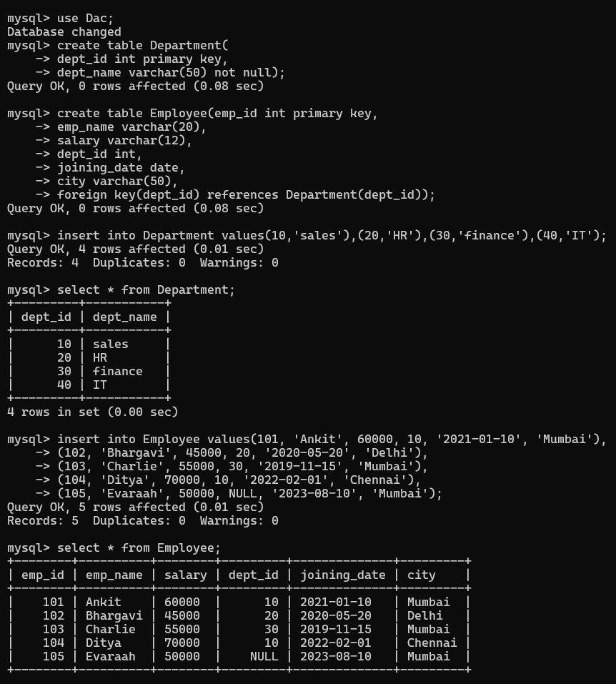

2. Write a SQL query to add any new column to an existing table.

Ans:-

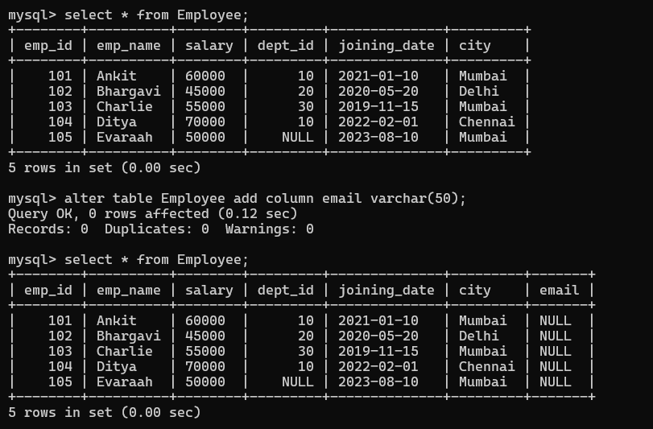

---------------------------------------------------------------------------------------------------------

3. Write a SQL query to insert multiple records (At least 5) into a table in a single operation

Ans:-

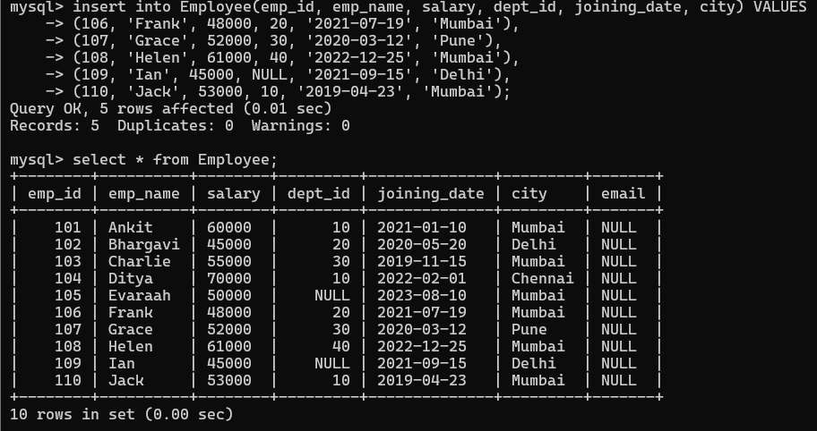

4. Write a SQL query to delete all records from a table.

Ans:-





---------------------------------------------------------------------------------------------------------

5. Write a SQL query to update salary records from a table where id = 5.

Ans:-

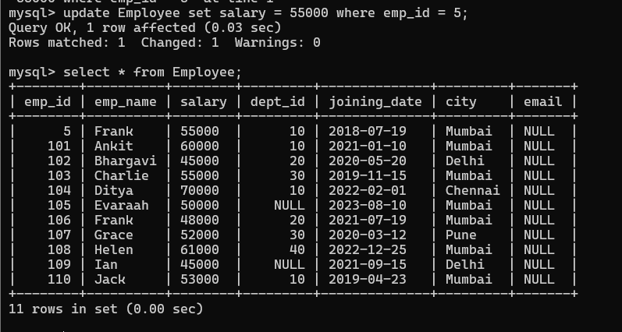

---------------------------------------------------------------------------------------------------------

6. Write a query to grant SELECT privilege on the Emp table to user readonly_user.Ans:- 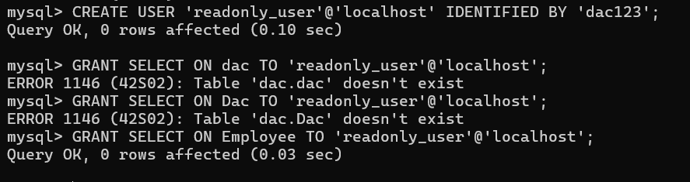

---------------------------------------------------------------------------------------------------------

7. Write a query to revoke INSERT privilege on the Emp table from user temp_user.

Ans:-

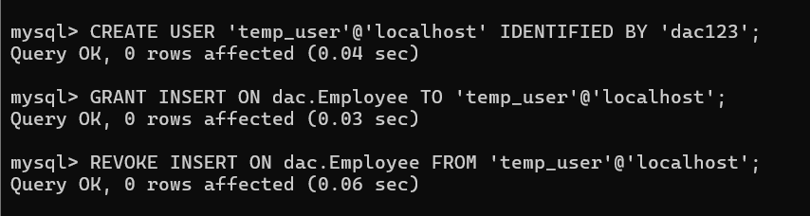

---------------------------------------------------------------------------------------------------------

8. Write a query to insert a new employee into the Emp table and commit the transaction.

Ans:-

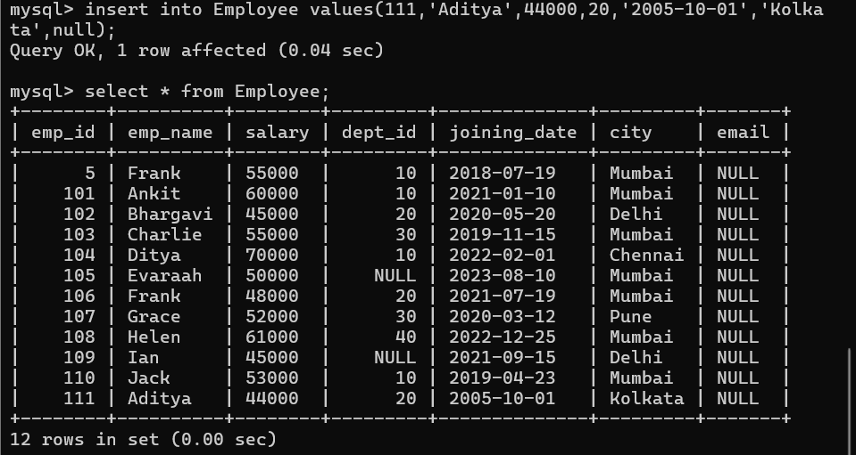

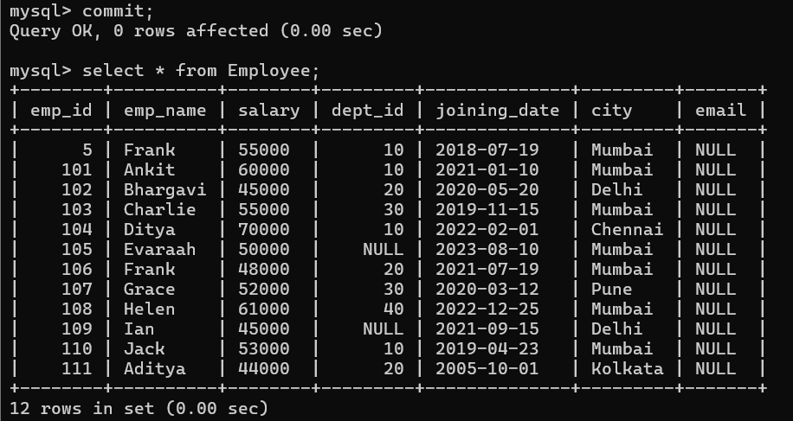

---------------------------------------------------------------------------------------------------------

9. Write a query to update the Salary of an employee with EmpID = 101 and commit the transaction.

Ans:- 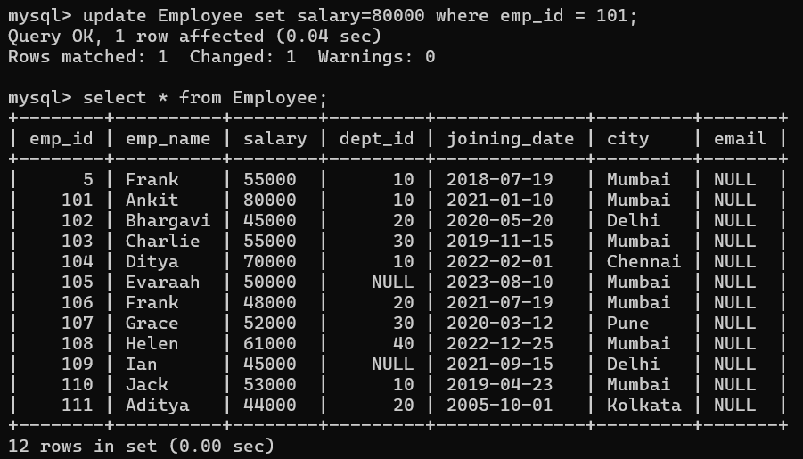

---------------------------------------------------------------------------------------------------------

10. Write a query to set a SAVEPOINT before updating the DeptID of an employee.

Ans:-



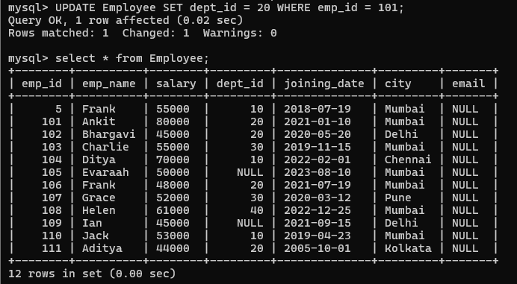

11. Write a query to rollback to the previously created SAVEPOINT.

Ans:- **mysql->**ROLLBACK TO SAVEPOINT before_dept_update;

---------------------------------------------------------------------------------------------------------

12. Write a query to truncate all data from the Emp table.

Ans:-

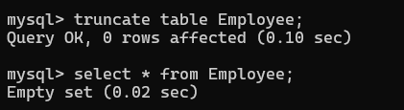

---------------------------------------------------------------------------------------------------------

13. Write a query to list all employees whose salary is greater than 50,000.

Ans:-

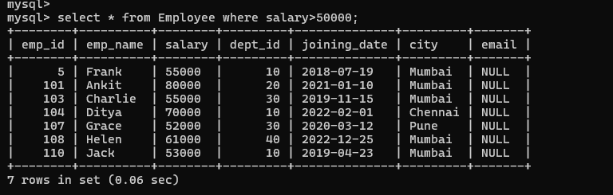

--------------------------------------------------------------------------------------------------------

14. Write a query to increase the salary of all employees in DeptID = 10 by 10%.

Ans:-

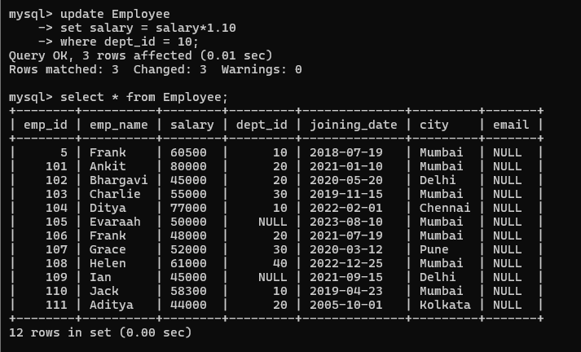

15. Write a query to count the total number of employees in each department.

Ans:- 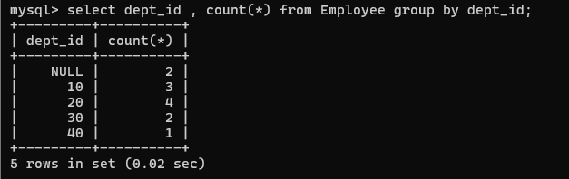

---------------------------------------------------------------------------------------------------------

16. Write a query to list departments that have no employees. & create a view for those salespeople who belong to the city of Mumbai.

Ans:- 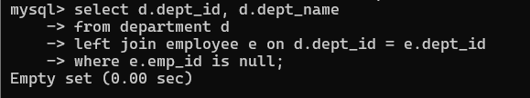

--------------------------------------------------------------------------------------------------------------------------------------

17. Write a query to display the highest salary among all employees.

Ans:-

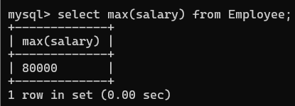

---------------------------------------------------------------------------------------------------------

18. Write a query to display the 2nd highest salary among all employees.Ans:- 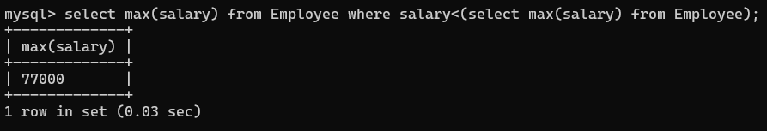

19. Write a query to show all employees ordered by JoiningDate in descending order.

Ans:- 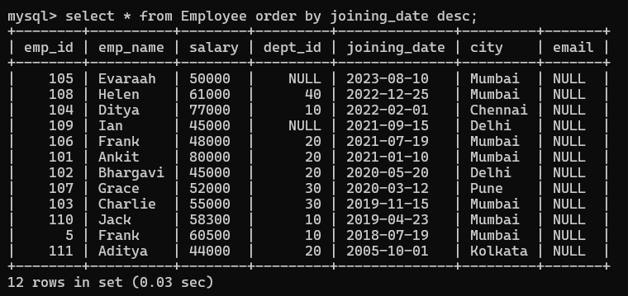

---------------------------------------------------------------------------------------------------------

20. Write a query to rename the DeptName column to DepartmentName.

Ans:-



